Recording a Rescue
Go to https://sowfi.secure.force.com/forms/apex/b3f__formcomplete?id=a1O2u0000000844EAA
Please note that the rescue form contains a large number of fields. Only the first 2 are compulsory (the date/time of the report, and the animal group), however the more information that is able to be captured, the more useful the report will be. It is understood however, that not all the fields will relevant to every rescue, and sometimes not all relevant information will be known.

The date/time of report can either be typed, or completed by pressing the calendar icon and selecting the date/time. (Approximate time is fine)
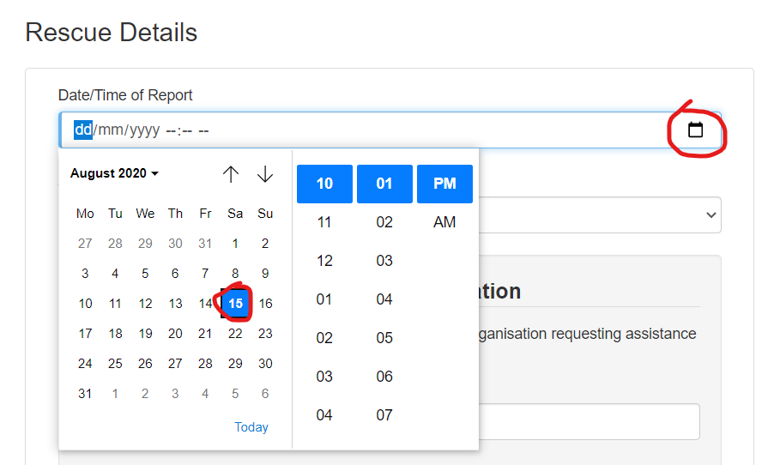
The animal group can be selected from the drop-down list. The animal groups have been developed by Wildlife Rescue Australia based on the most accurate identification typically possible from a description by a member of the public.
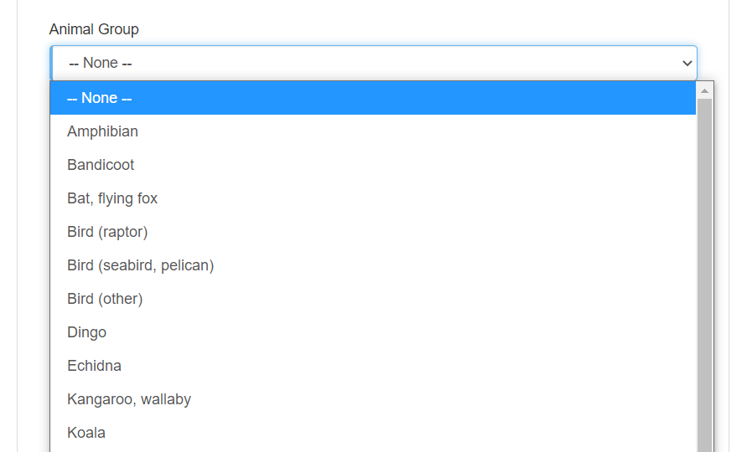

Please enter any information you have about the person or organisation that requested assistance. This will make it easier if they need to be contacted later about release
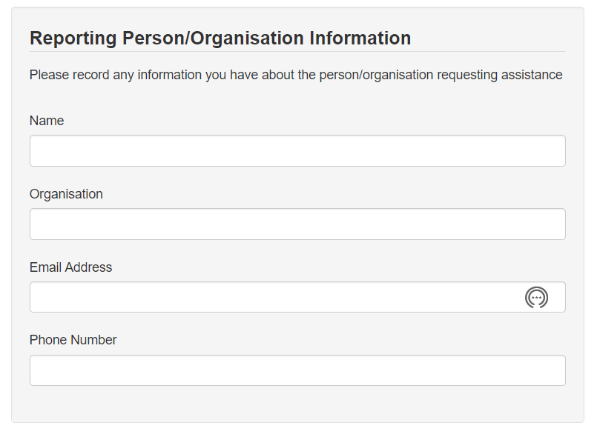
If the circumstances were unusual or noteworthy, please enter a brief description
Start typing your name (or the name of the person who did the rescue if filling in the form on their behalf). Select your name from the search results that appear
Select the status of the rescue as at the time of completing the form
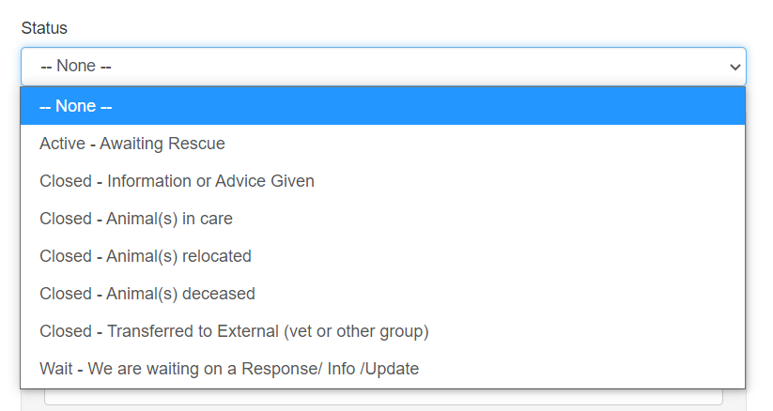
Enter the street and suburb of the rescue (or where the report was made if no rescue occurred). This is particularly important for rescues where an animal comes into care.
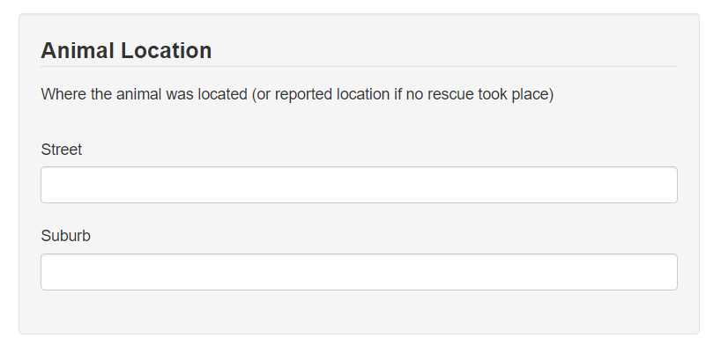

If a rescue took place, please continue and enter the animal details. If no rescue occurred, scroll down and submit the form.
Most rescues will only relate to a single animal. However, if multiple were rescued, the add button can be used to create additional animal records.
If you do enter details of an animal, the species field is compulsory, but all known details should be entered.
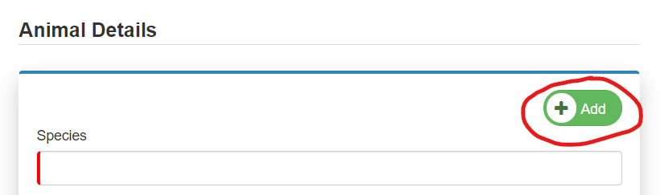
Start typing the species common name, and select from the search results
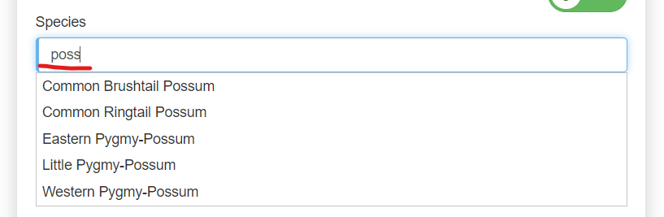
Choose the most relevant reason that the animal needed rescue (to the best of your knowledge)
Complete the life stage of the animal at the time they were rescued. Enter the gender (if this has been ascertained)
Select the current status of the animal in the outcome field. This can be updated later if it changes.
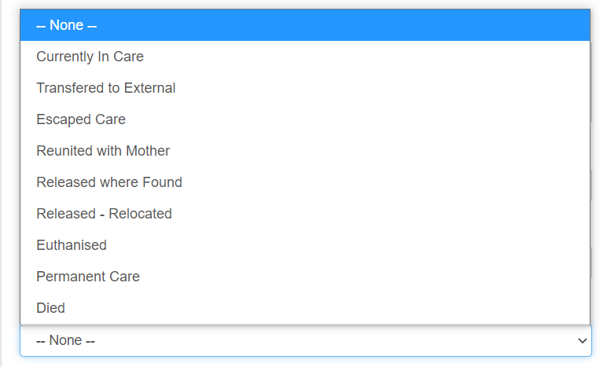
If you’ve chosen to name the animal, enter their name

Press submit

You will receive a success message once the form is submitted. Provided a valid email address is held for the member conducting the rescue, an email will be sent within a few minutes, confirming details of the rescue and providing links to update animal details or transfer the animal to a new carer.

