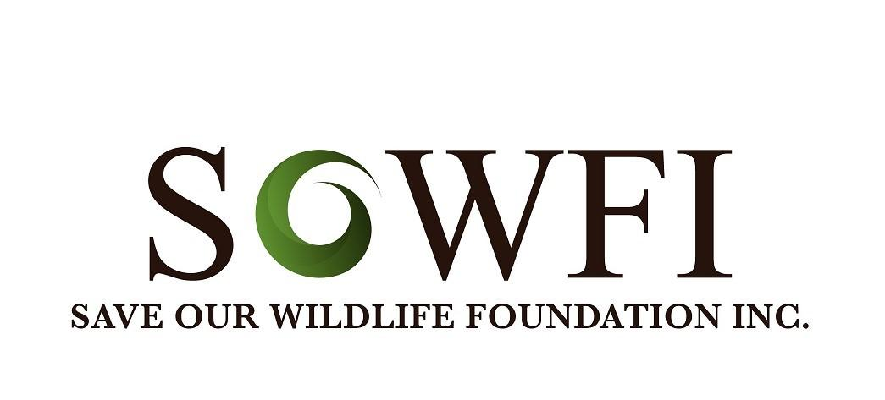
Code of Ethics for Wildlife Carers/Rescuers
1. A wildlife volunteer should strive to achieve high standards of animal care through knowledge and an understanding of the field. Continuing efforts must be made to keep informed of current rehabilitation information, research and regulations.
2. A wildlife volunteer should be responsible, conscientious, and dedicated, and should work continuously toward improving the quality of care given to wild animals undergoing rehabilitation.
3. A wildlife volunteer must abide by local, state and federal laws concerning wildlife, wildlife rehabilitation, and associated activities.
4. A wildlife volunteer should establish safe work habits and conditions, and abide by OHSW practices at all times.
5. A wildlife volunteer should acknowledge limitations and enlist the assistance of a veterinarian and other trained professionals when appropriate.
6. A wildlife volunteer should respect other volunteers and persons in related fields, sharing skills and knowledge in the spirit of cooperation for the welfare of animals.
7. A wildlife volunteer should place optimum animal care above personal gain.
8. A wildlife volunteer should strive to provide professional and humane care in all phases of wildlife rehabilitation, protecting the welfare, respecting the wildness, and maintaining the dignity of each animal in life and in death. Releasable animals should be maintained in a wild condition and released as soon as appropriate. Non-releasable animals that are not appropriate for education, foster-parenting, companionship, or captive breeding have a right to euthanasia.
9. A wildlife volunteer should encourage community support and involvement through volunteer training and public education. The common goal should be to promote a responsible concern for living beings and the welfare of the environment.
10. A wildlife volunteer should work from a foundation of sound ecological principles, incorporating appropriate conservation ethics and an attitude of stewardship.
11. A wildlife volunteer should conduct all business, activities, and communications in a professional manner, with honesty, integrity, compassion, and commitment, realizing that an individual's conduct reflects on the entire field of wildlife rehabilitation
Adapted from: US National Wildlife Rehabilitation Association & International Wildlife Rehabilitation Council Code of Ethics

